Preparing for Payroll Master Checklist

Month ___________________________________________________________________

- Create Payroll Backup folders
- Create a HR Back up and put in Folder.
- Submit TRS Active Care bill through TexNet by the 10th of the month.
_____4. Add any new employees
_____5. Update employee info if needed
_____6. Verify Retiree Surcharges (only pay during months’ retiree physically works)
_____7. Reconcile all deductions to bills and add/modify deductions as needed
_____8. Create & send Pre-note if needed
_____9. Import from Timekeeping/Leave software for Leave, Substitutes and/or Hours/Pay Transmittal, if able.
_____10. Manually Enter Leave, substitutes and/or Hours/Pay Transmittals, if needed.
_____11. Manually Enter Hours/Pay Transmittals if needed
_____12. Check the Contract Variance Report (HRS6050) and correct as needed
_____13. Verify transactions and Pre-Post reports

Details
_____1. Create Payroll Backup folders for the month
Recommendation: Create a Master Payroll Folder with the sub folders listed below. Each month make a copy of the Master Payroll folder and rename to include the month and year. When directed, create backups or reports during the payroll process and save in the folder indicated. Feel free to add to the list below as desired for your district.

- EFT File  - TRS  - Child Nutrition Worksheet  - Payroll Reports | - Backups  - Transfer Transactions  - Accrual Variance  - TWC

_____2. Create a HR Back-up by choosing the Export Human Resources by Payroll, Choose the Monthly CYR, Execute and put in Backup folder.

Utilities > Export Human Resources by Payroll

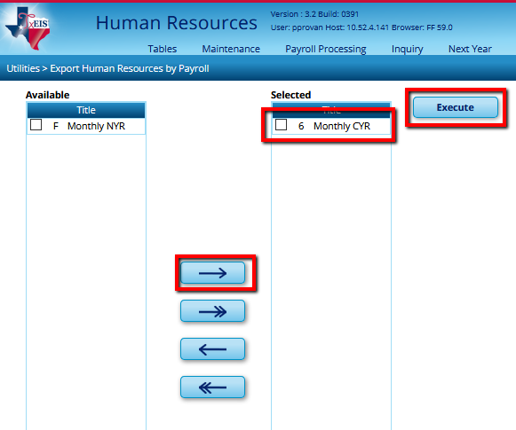

_____3. TRS Active Care
  - By the 10th of the month pay the TRS AcitveCare Bill through TexNet.
You must pay the TRS ActiveCare bill as it is shown, even if the bill is inaccurate. Pay entire bill, then enter changes in the BSwift portal or alert your Third Party Administrator (TPA). You should receive an email letting you know when the corrections have been made. Make note so you can verify changes were made next month and all additional charges or credits are applied correctly. If you do not receive confirmation of the change, contact your BA advocate or your TPA.

- Download TRS Active Care bill from:
https://trsactivecare.bswift.com

  - Choose your District
  - Enter Username & Password
  - Click on Library and choose Content Admin
  - Choose the monthly bill you are needing in either Excel or PDF

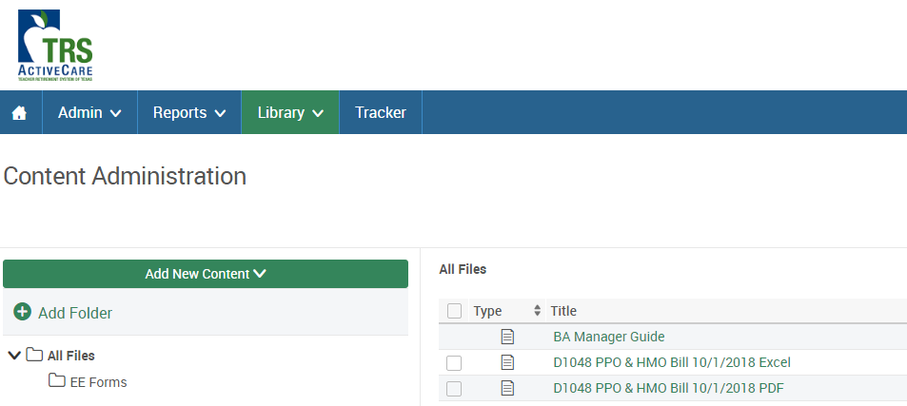

- Submit payment via TexNet online at: https://texnet.cpa.state.tx.us
- Click on ‘Continue to TEXNET Login’

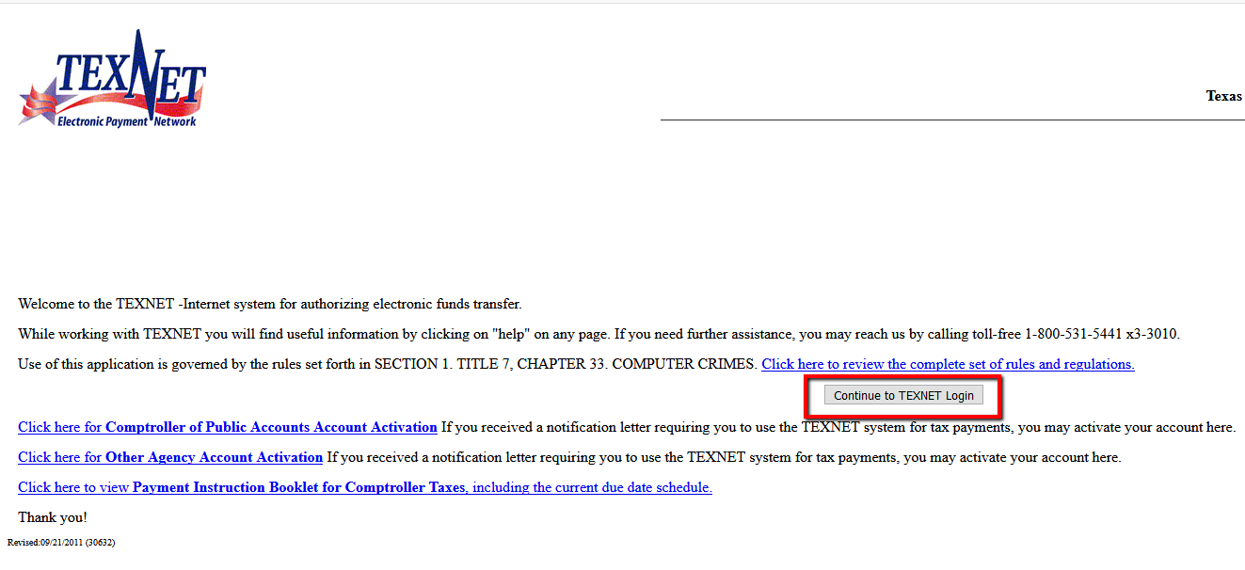

- Enter the Identification Number, Location, and Password then click submit.
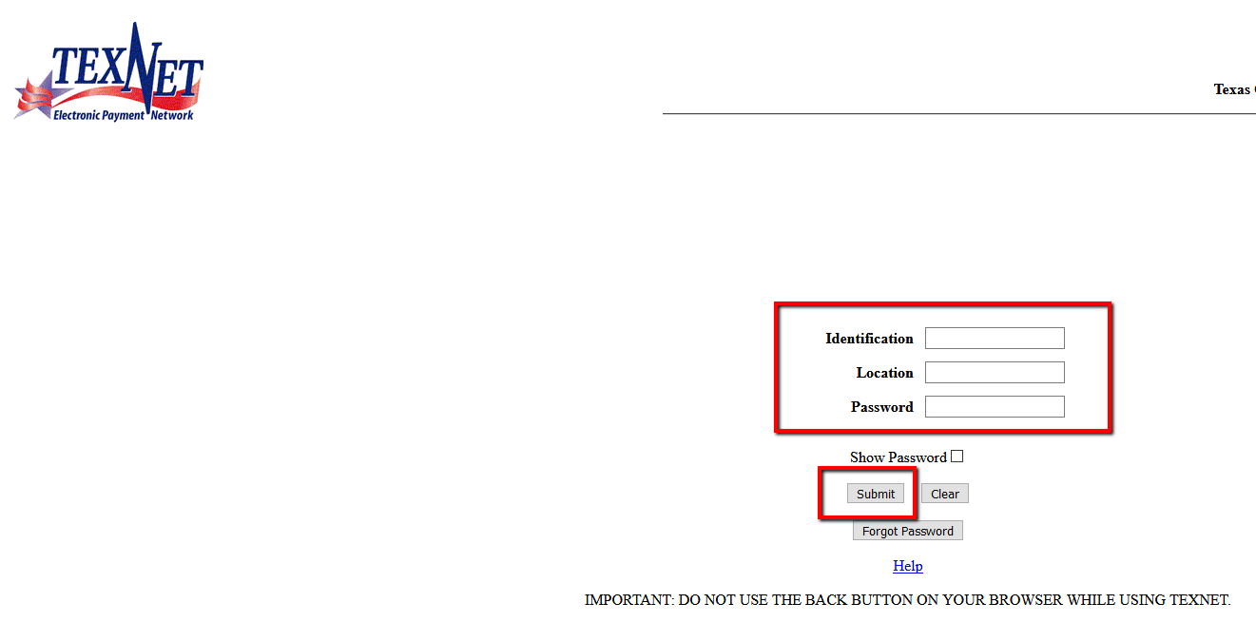
- Click Add
- Enter Total Amount from the TRS Active Care Bill.
- Enter the Settlement Date:
- Report Month: You will start with 01 as September, 02 will be October, 03 will be November and so on. Example: Report Month 09 is for May.
- Enter the Total TRS – Active Care Premiums Billed Amount
- Submit

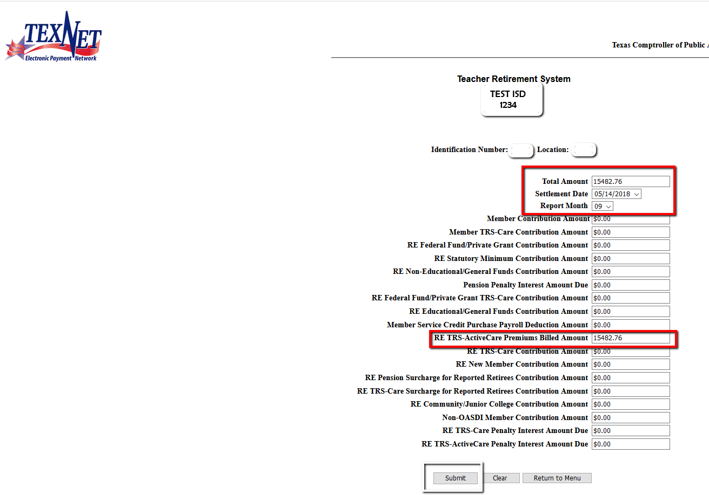

- Once Submitted you will receive ‘Transaction Complete’ with a ‘Trace #’. It will show the Total Amount, Settlement Date, Report Month and the RE TRS –ActiveCare Premiums Billed Amount.
- Save the Transaction Complete form, your TRS ActiveCare Bill and your Health Care Transfer Transaction form together in your Transfer Transaction folder.

  - Transfer funds to payroll clearing account at the bank if applicable.

  - Record Active Care payment as Transfer Transaction – It is recommended that amounts for all transfer transactions and cash transfers be recorded on the Transfer Transaction worksheet available on our website.

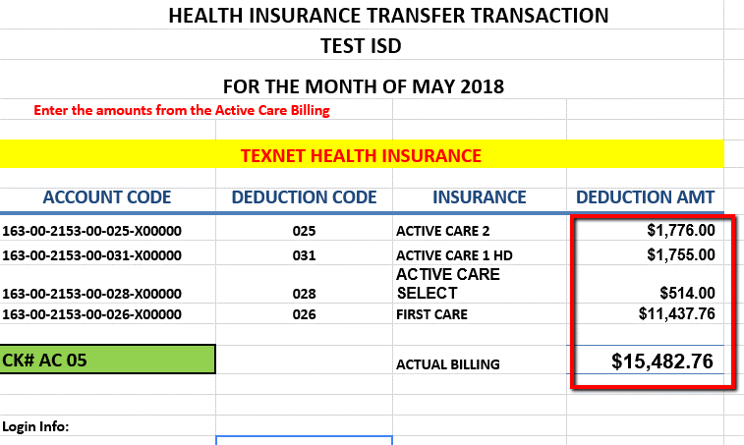

- Record Active Care Payment in TxEIS

Utilities > Transfer Transaction Processing > Transaction Maintenance tab,

- Click +Add to enter data for this payroll.
- Enter the Pay Date
- Vendor Name (typically TRS).
- Leave the Employee Number and Deduction Code columns blank.
- Enter the deduction amount (total for the health insurance plan).
- Enter account codes shown on the Transfer Transaction Worksheet. Your account codes may be different then those shown.
- Add additional lines as needed for each health insurance plan, Refresh Totals, and ensure transactions equal the total transfer.
- Save.

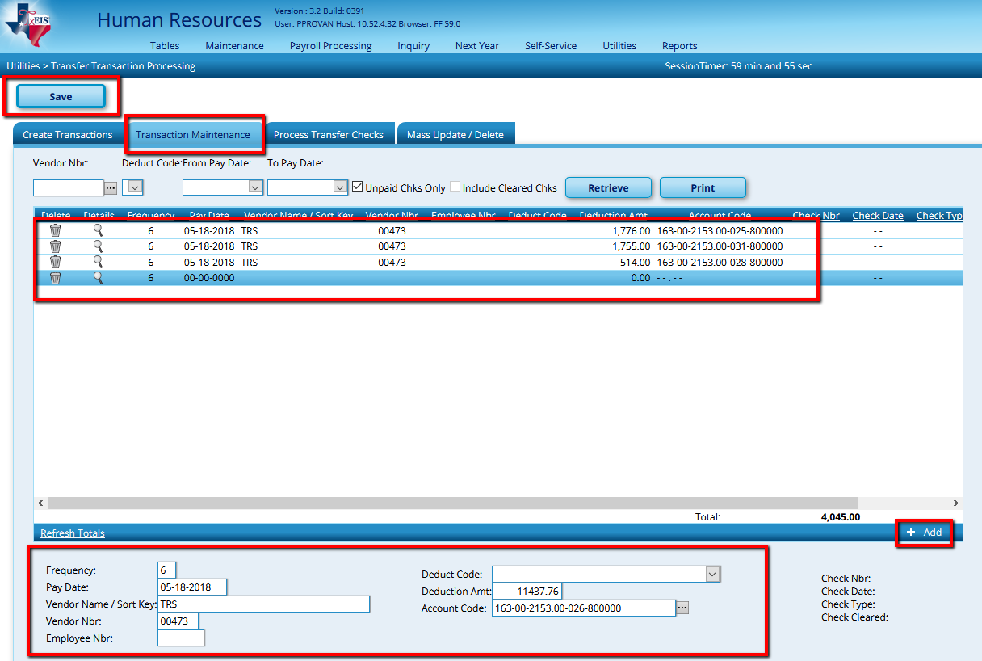

- On the Process Transfer Checks tab, select the appropriate accounting period, select Payroll check stock, enter the Desired Date as the Check Date and click Preview.

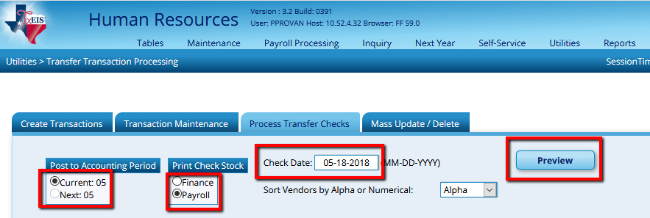

- Assign a check number. (Recommend ACMM where MM is the pay month.) Review for accuracy and select Next.

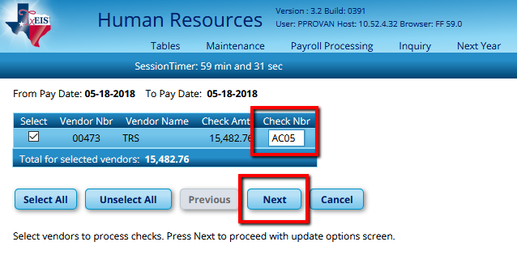

- Check the top 2 boxes. Do not check to Print the Fund Transfer Summary as these amounts were included in your payroll transfer. Click Update.

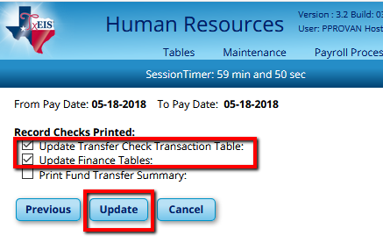

- At the prompt, make a backup and save in the Transfer Transactions folder within the monthly payroll folder.

- Add any new employees.
- Update employee info if needed. Examples include:

  - Name Changes, address changes, etc… will need to be included in TRS so keep list to verify when completing that reporting.
  - Adjustments to pay
  - Changing jobs – recommend paying off old job and adding new as a separate line
  - Employee payoff – complete Payoff worksheet & have employee sign
  - Direct Deposit information/changes

- Consider Retiree Surcharges (only pay during month’s retiree physically works at district)

  - Surcharges apply ONLY to retirees working more than half time, who retired after September 1, 2005 and ONLY on months when they are physically working at the district. This can be verified on the TRS website. If the retiree surcharge is applicable, select the Take Retiree Surcharge box for each applicable employee at

Maintenance > Staff Job/Pay Data > Employment Info tab.

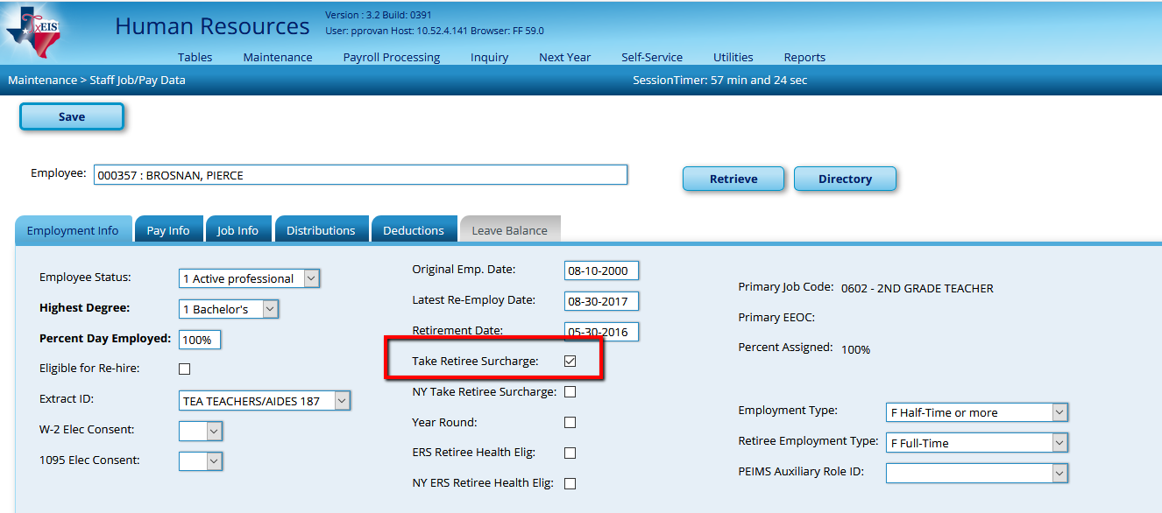

  - The TRS website will also indicate whether the Pension CARE Surcharge is due. If so, add a line for the TRS CARE Surcharge deduction for each applicable employee as an Emplr Contrib. The amount will be $535.00 unless otherwise directed by TRS.
Maintenance > Staff Job/Pay Data > Deductions tab

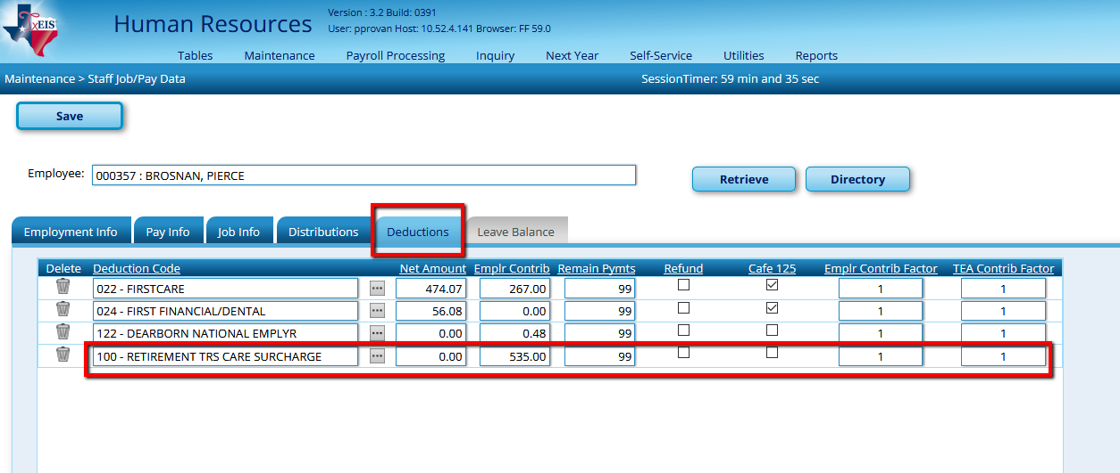

NOTE: If the district chooses to recoup some or all of the surcharges by charging those to the employee, we recommend entering an additional deduction payable to the district for the amount agreed upon here.

- Reconcile all deductions to bills and add/modify deductions as needed.
Payroll Processing > Run Payroll
  - Select the Pay Date and Retrieve.

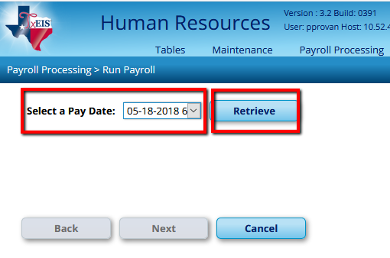

  - Verify all current deductions are selected in the Deductions table at the bottom right of the screen and select Next.

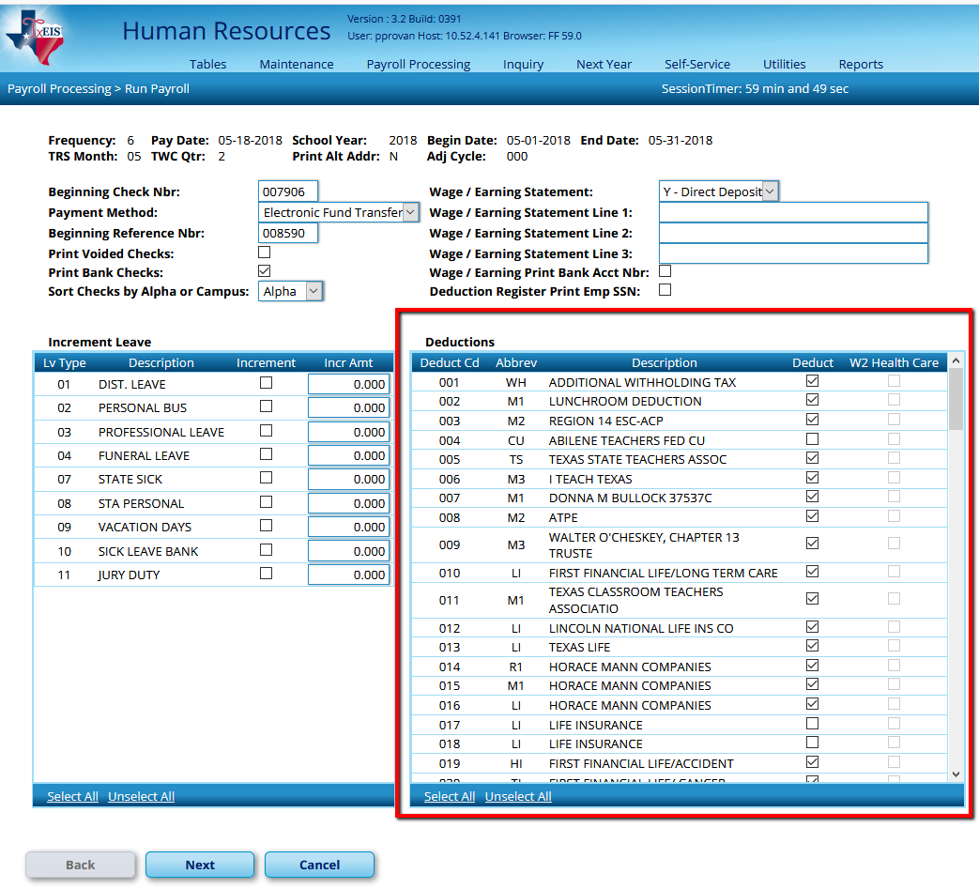

  - Move employees to the right and Select Next.
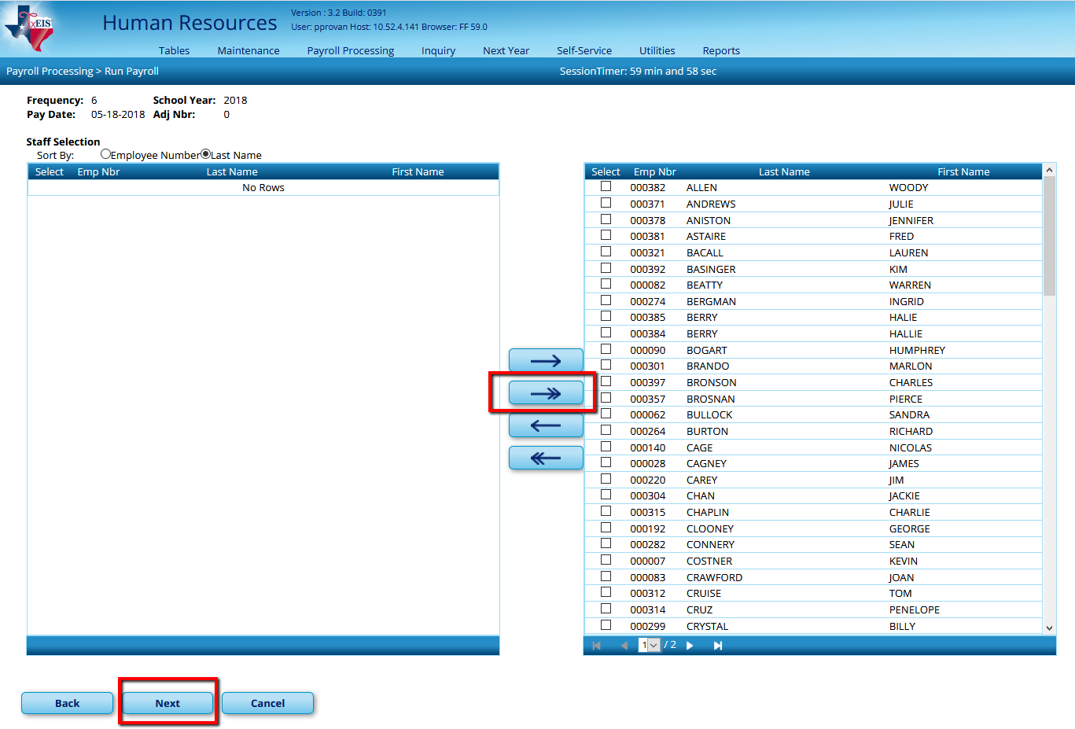

  - Select Payroll Calculations for a regular payroll run, click on Next,

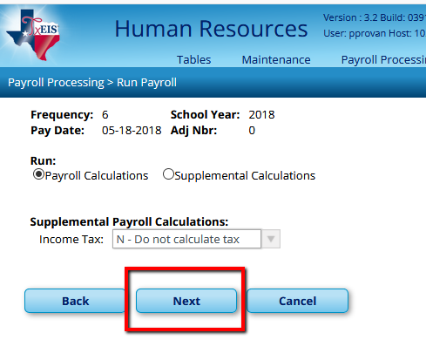

  - Click on run Calculations

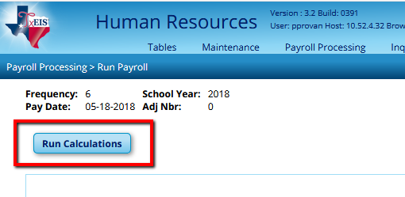

  - Review the Payroll Calculations report for any payroll failures or warnings. Employees with a warning message will still get paid, but there is an issue that may need to be resolved. Employees with a failure message will not receive a paycheck at all. Resolve all problems before continuing. When the reports indicate that No Errors were found, select Next.

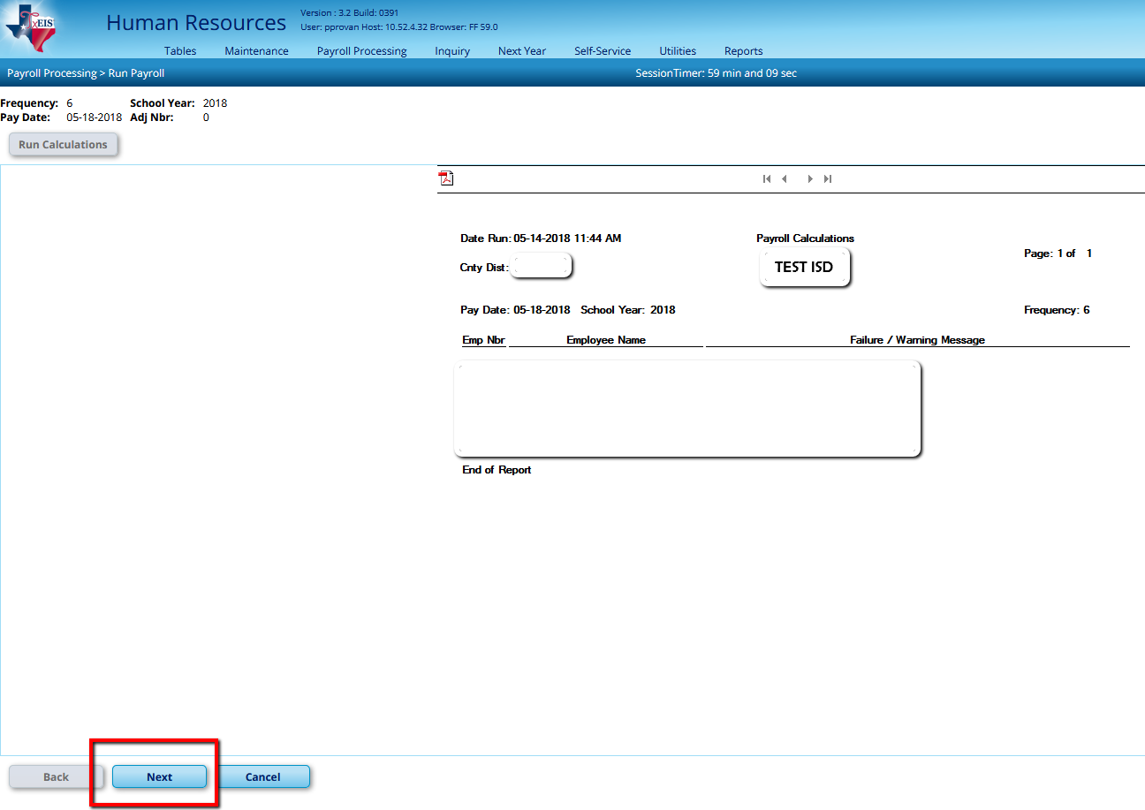

  - Select the Deduction Register, sorting by Deduction Code (D) and Generate Reports.

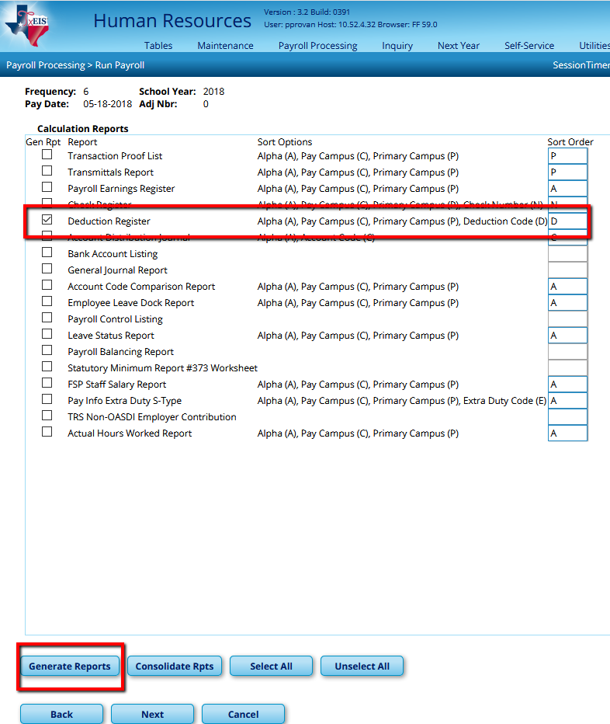

- Print all pages and use to reconcile all deductions for which you receive an invoice. Remember for TRS Active Care, you must send the amount on the TRS invoice. If there is a discrepancy, ensure steps are taken to correct the problem on the next invoice. If an inactive employee is listed, you will need to transfer additional money from Local Maintenance to Payroll Clearing at the bank.

- Compare other deduction reports to any invoices you have for accuracy.

- Add or modify other deductions as needed. Common examples:
    - Lunch charges
    - Rent
    - Electricity/Gas/Water - Utilities
    - Day care fees
    - Other misc. deductions

- Create & send Pre-note if needed
  - Pre-notes should be sent to the bank on new employees and/or employees whose bank information changed, to ensure direct deposits will clear on payday. This file will only include the employee’s name, bank routing number and account number (no amounts.)

Maintenance > Staff Job/Pay Data > Pay Info tab

- Select the Pre-Note box for all affected employees. (Once the Pre-Note is created, the box will automatically be removed by the system.)

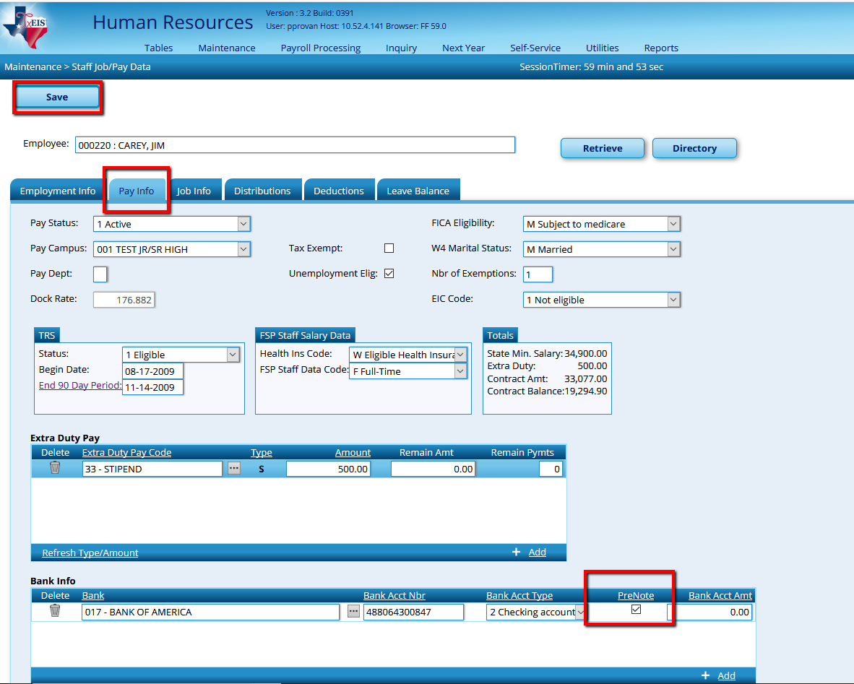

Payroll Processing > EFT Processing > Create EFT File tab

- Select Pre-Note. Enter an effective date equal to the date you will send the file for testing and Create the EFT File. Save the file in the EFT file within the Payroll folder.
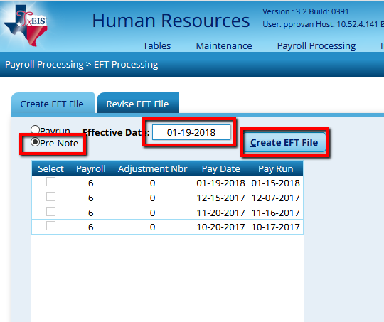
- Send the file to the bank and ask them to run it through ACH. The bank will be able to verify the validity of the information in the EFT. All errors must be corrected for an employee to receive their direct deposit on pay day.

If you use a Timekeeping and/or Leave tracking software, you may import the data to TxEIS rather than manually entering Leave, Substitutes, and Hours. Complete step 9.

If you do not use a Timekeeping and/or Leave tracking software, enter Leave, Substitutes and Hours manually as shown in step 10.

Or, use a combination of steps 9 and 10 if needed.

Import Process
- Import Leave, Substitutes and Hours Pay transmittals from Timekeeping software.
Create Import file with the name TIMETRN6.TXT according to the instruction from your timekeeping software.

NOTE: 6 = Monthly pay frequency. If your district has a pay frequency 4 or 5 a separate file will be needed for that frequency and the name changed to TIMETRN4 OR 5.txt

- Import Hours & Substitutes
Human Resources > Utilities > Merge Payroll Transaction Files
- Select Data Transmittal
- Choose the Paydate
- Browse and select Import transmittal file (TIMETRN6.TXT).
- Select Primary Job
- Execute

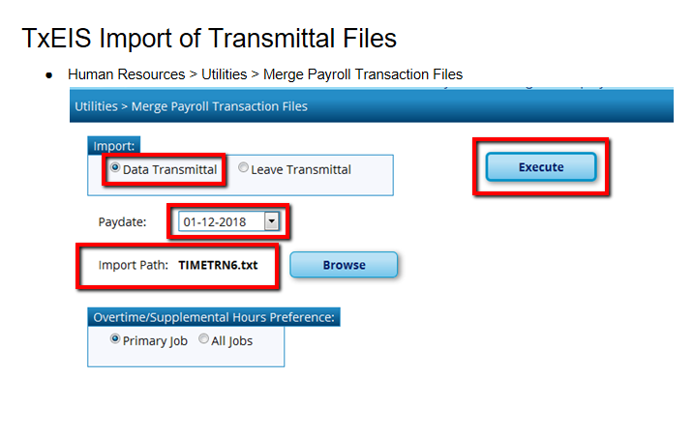

- Verify and Correct Errors on the Report.
Error listing: If errors are present, you should cancel the process, make corrections in the timekeeping software and create a new file to import. If you select Process at this point, only transactions with no errors will be imported.

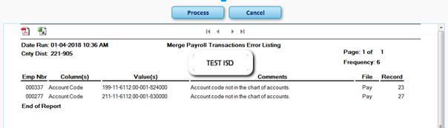
- Once Error Listing is blank, select process to import transactions.
- Import Leave Transmittals
Create Import file with the name TIMELEV6.txt according to the instruction from your timekeeping software.
NOTE: 6 = Monthly pay frequency. If your district has a pay frequency 4 or 5 a separate file will be needed for that frequency and the name changed to TIMELEV4 OR 5.txt

- Select Data Transmittal
- Choose the Paydate
- Browse and select Import transmittal file TIMELEV6.txt.
- Select Primary Job
- Execute

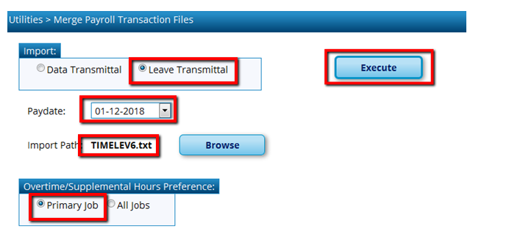
Error listing: If errors are present, you should cancel the process, make corrections in the timekeeping software and create a new file to import. If you select Process at this point, only transactions with no errors will be imported.
- If there are no errors on the leave transmittals, then everything will be imported from your Leave Tracking Software into TxEIS.
- Click Ok and then Process
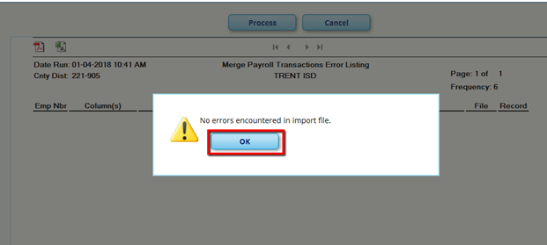
C. Verify transactions imported correctly.

Reports > HR Reports > Payroll Reports > Proof List of Payroll Transactions

Please verify all information on the report with the staff absence report and print summaries for your hourly staff and all substitutes in your Time Keeping Software.
Anything that did not get updated, you will have to manually put in TxEIS at this time.

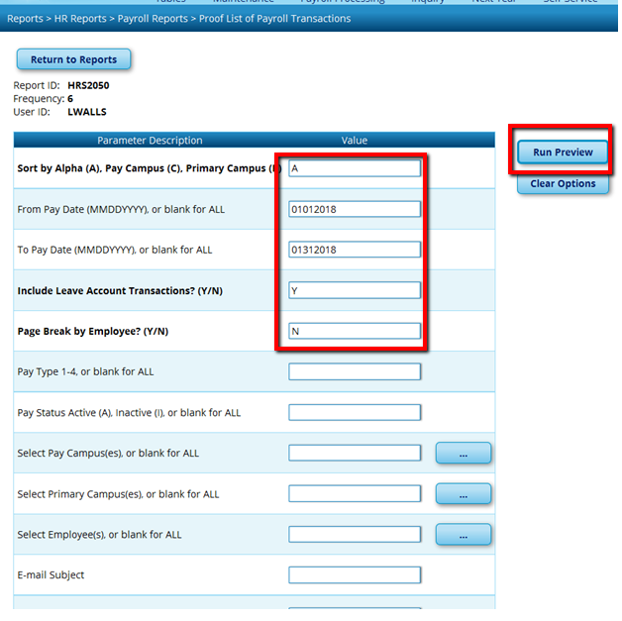

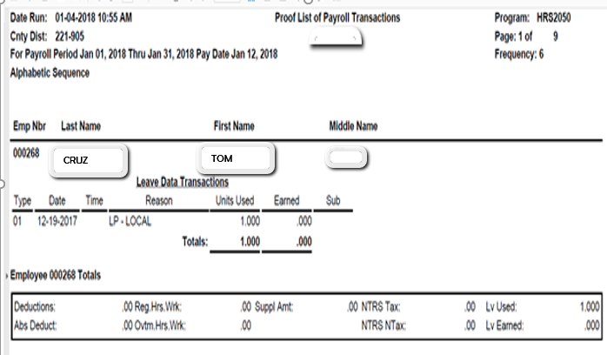

Manual Process
_____10. Enter Employee Absences
      - Employee Absent Without Sub.

Maintenance > Leave Account Transactions > Staff Leave Maintenance tab

- Click on the +Add button at the bottom of the screen
- Select the Pay Date
- Abs/Earned Date - Date of the Absence,
- Leave Type: Use the Ellipses to select from possible choices as needed.
- Leave used.
- Save changes.

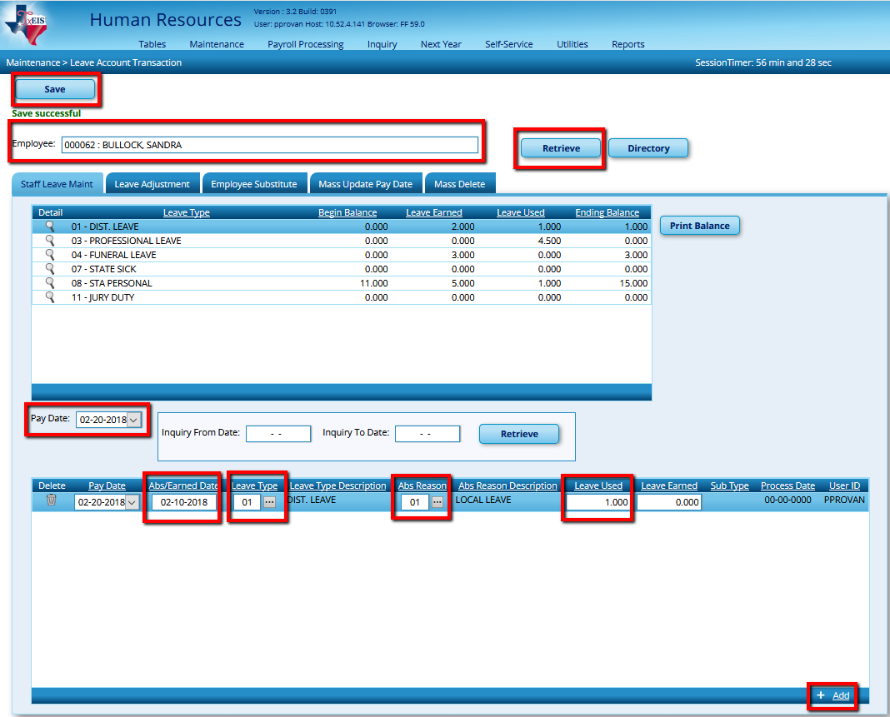

      - Employee Absent with Sub:

Maintenance > Leave Account Transactions > Employee Substitute Tab

Top portion:
- If a sub is working as an extra (not for a specific employee) leave this area blank. Below, enter the Pay Date the sub will be paid and the Sub’s name and Retrieve. Or see step 11d as an alternative way to pay these subs.
- Select the Pay Date
- Click Retrieve
Substitute Information:
- Select the Sub Frequency
- Select the Sub Pay Date
- Enter the Sub’s Employee Nbr or the Sub’s Name. Click Retrieve

Middle section: Emp Leave and Sub Pay Detail:
- Choose the Sub Type
- Enter the Absence Date
- Leave Type: you can choose from the Leave Type listed at the bottom of the screen or choose from the ellipses button.
- Leave Used: Sub units should be 0.5 to indicate a half day or 1.0 for a full day.

Distributions for Substitutes section:
- Click the +Add
- Verify the Substitute Account Code. If it does not pull up automatically then you will need to enter. If the sub was simply extra help, with no employee absence, a blank line will be added for you to enter the desired code. All account codes can be modified
- Actual Hrs
- Actual Date
- Verify Campus ID
- Percentage - percent of pay charges to this account must equal 100% when all accounts are totaled.
- Verify the Pay Amt.
SAVE.
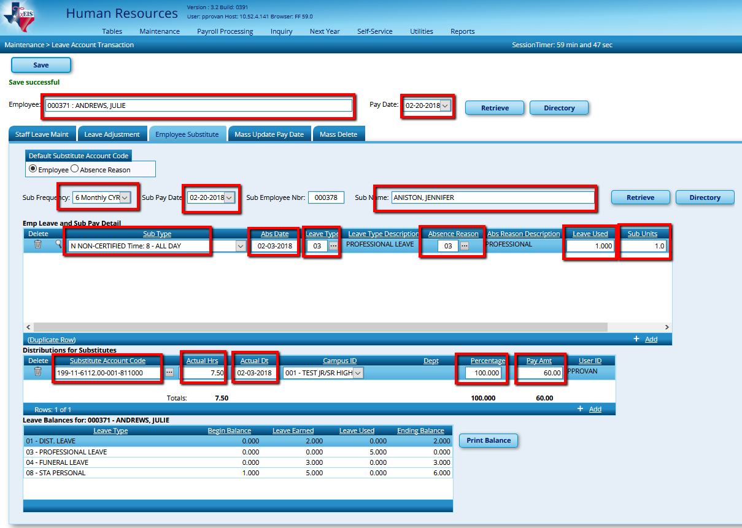

NOTE: See Step 11 C - Extra Duties for entering substitutes not subbing for an employee.
_____11. Enter Hours/Pay Transmittals

To Enter Hourly Employees for Pay Type 3

a. Create Hours

Maintenance > Hours/Pay Transmittals > Create Hours

- Select the Pay Date
- Click Retrieve
- Hours: Select Regular. Overtime will be recorded on the Ovtm Hours tab.
- All Hourly employees will appear on this screen.
- Enter the Reg Hours
- Click SAVE.

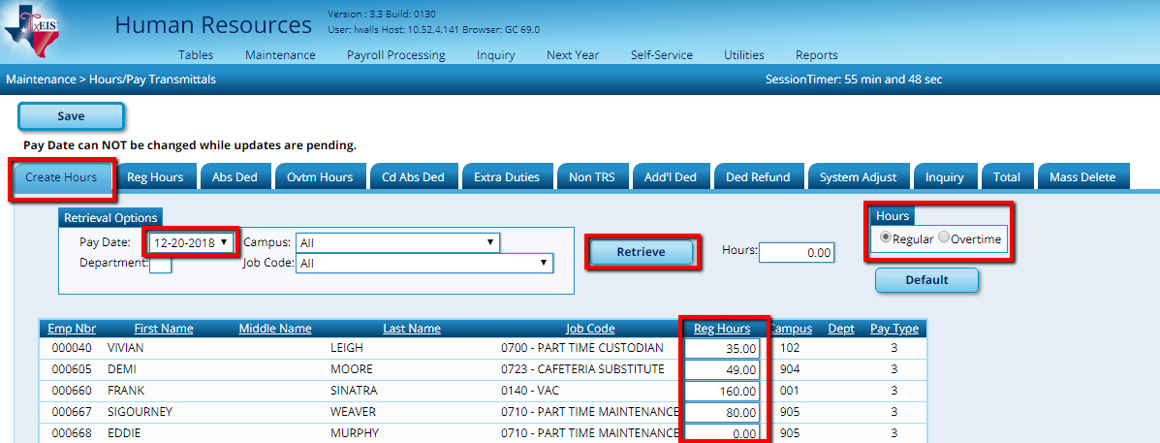

  - Reg Hours: Continuation of Entering Hourly Employees –

Maintenance > Hours/Pay Transmittals > Reg Hours

- Select Paydate and Retrieve
- Edit Regular Hrs,
- Actual Hrs
- Actual Date
- SAVE

NOTE: Save information entered on each tab before leaving the tab.

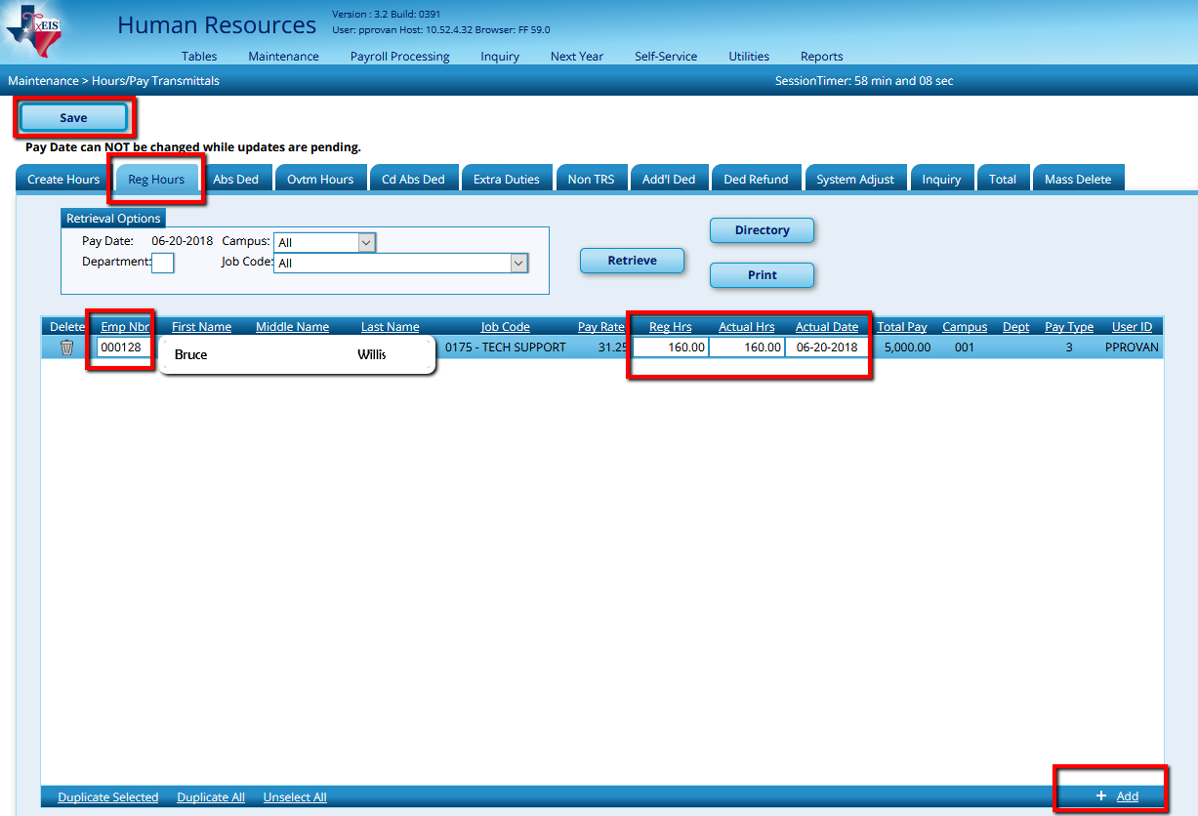

c. Overtime hours for Pay Types 2 & 3

Maintenance > Hours/Pay Transmittals > Ovtm Hours

- Select the Pay Date
- Retrieve
- Enter the Emp Nbr or choose Directory if unknown.

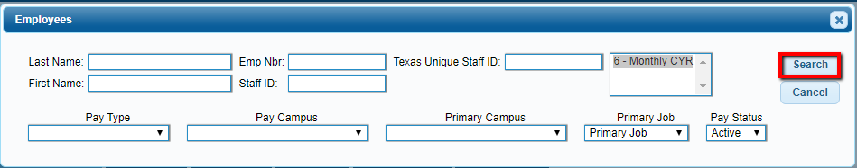

- Enter the Account Code.
- Number of Overtime hours then tab. TxEIS will calculate the overtime amount based on the overtime rate in the employees Job Info tab.
- Actual hours – this is the actual overtime hrs. only – not hours X 1.5.
- Actual Date
- Reason for the overtime, if desired.
- SAVE.
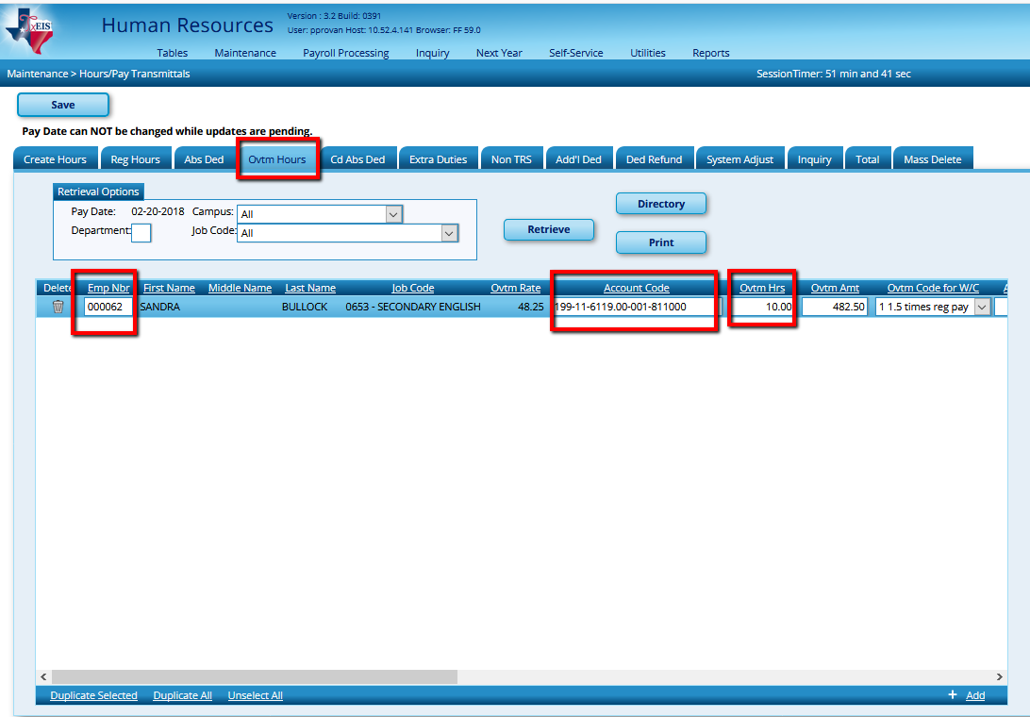
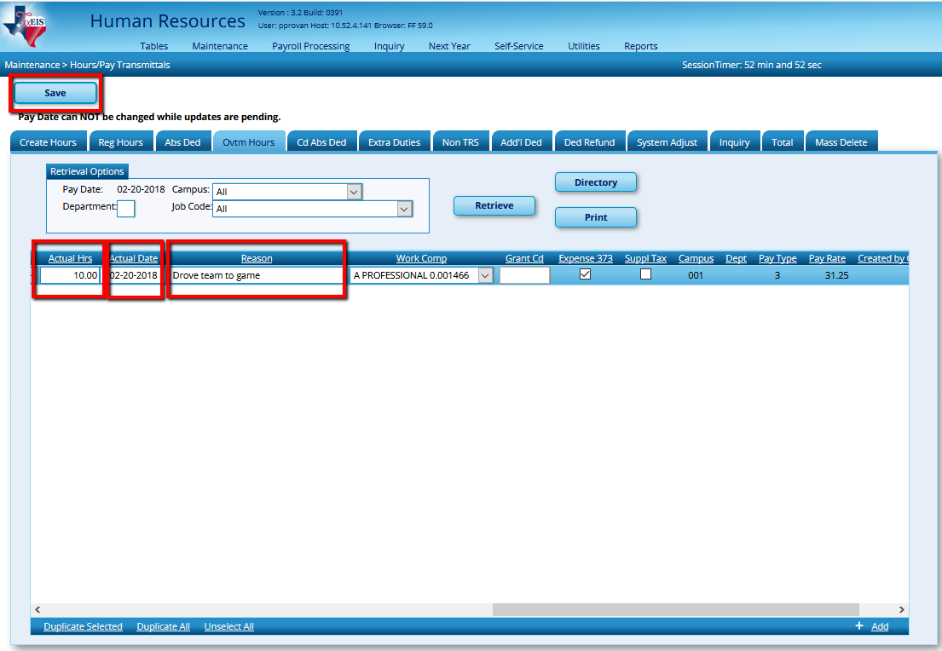

d.Extra Duties - All Pay Types

Example: Gate, Time Clock keeper at Gate, ISS, Tutorials,
Substitutes not tied to an employee etc.

Maintenance > Hours/Pay Transmittals >Extra Duties

- Enter the Emp Nbr or choose Directory if unknown, then TAB
- Enter the Account Code
- Extra Duty Amt. or Substitute pay
- Actual Hrs
- Actual Date
- Reason for the Extra Duty
- Save
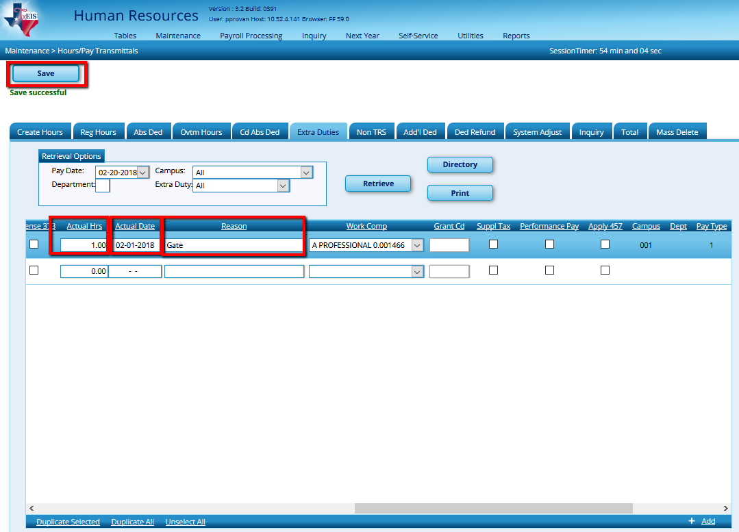
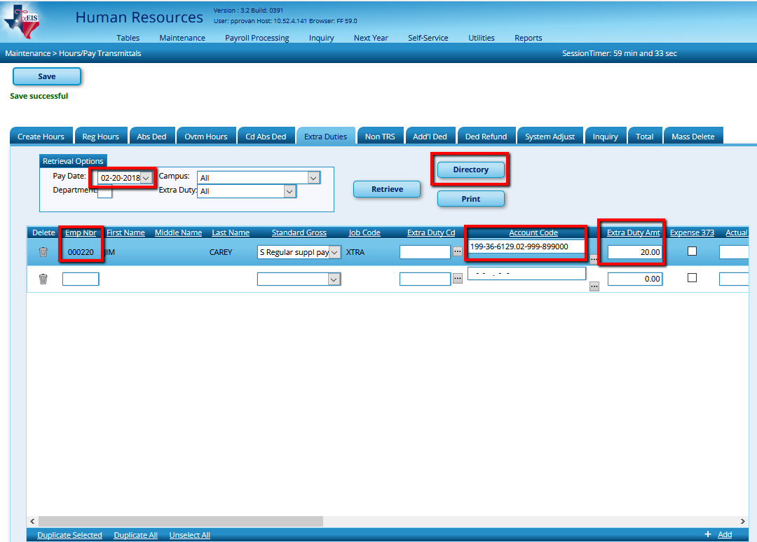
- Non-TRS – All Pay Types

Maintenance > Hours/Pay Transmittals > Non TRS

Example: Employees who receive non-TRS supplemental pay amounts such as travel and uniform allowances and TRS ActiveCare allowances taken as compensation. Nontaxable amounts also are not included in unemployment, FICA, TRS, and withholding tax calculations

- Enter the Emp Nbr or choose Directory if unknown, then TAB
- Verify or Enter the Account Code
- Payment Code: Click to select whether to pay not pay

Example:
- If N Do not pay is selected, the Payment Type field automatically is set to 2 - Non TRS Bus Allow, and the user cannot modify. Transactions using this combination will not display on the Account Distribution Journal, but are displayed on the Payroll Earnings Register, Check Stub, and Calendar YTD report.
- If you are reimbursing an employee for a meal during travel, you will select Payment Code Y to pay the employee.
- If however, the employee used a school credit card so you don’t have to reimburse him, but do need that reimbursement on his W-2, select Payment Code N so the amount is not added to his paycheck.
- Choose the Type of Payment and enter the amount in Taxable or Non Taxable as applicable. Enter a reason for the Non TRS amount
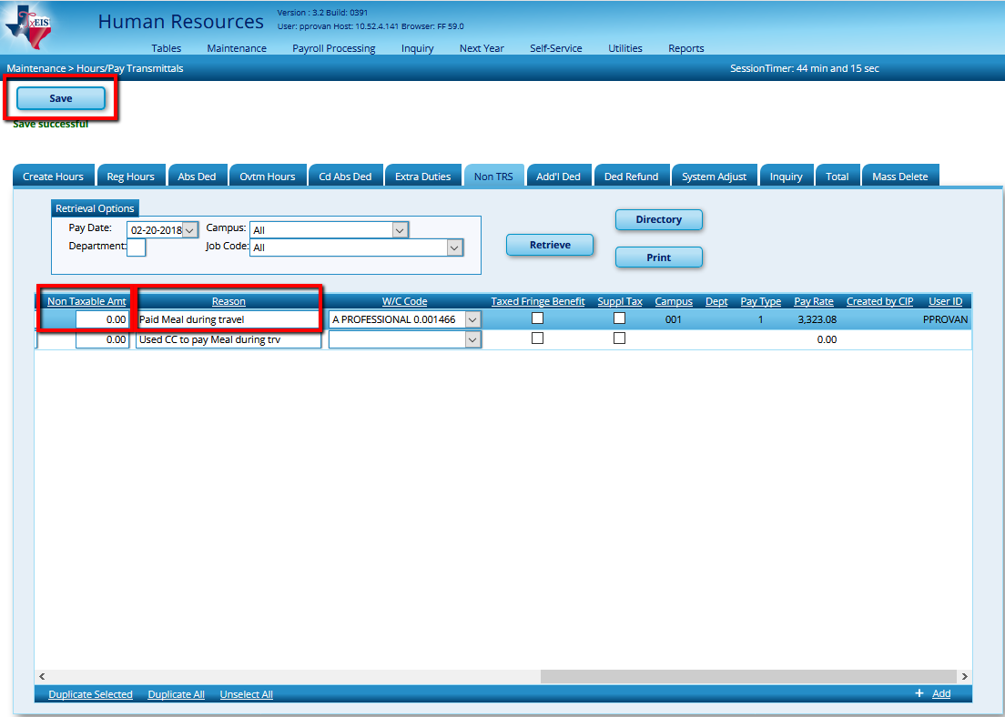
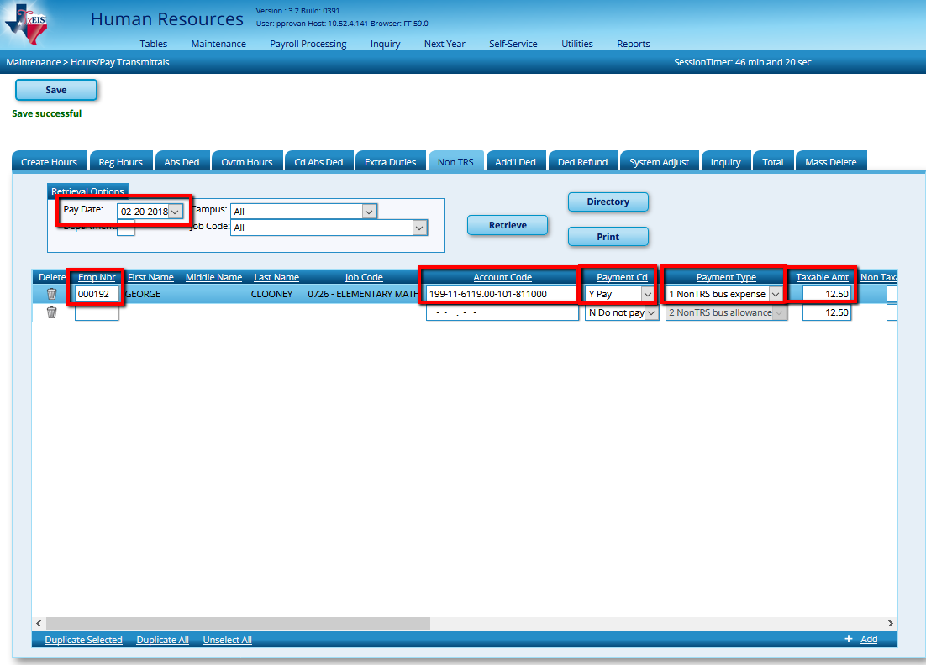

- Additional Deductions – All Pay Types

Maintenance > Hours/Pay Transmittals > Additional Deductions

This tab is used to maintain records of additional deduction transmittals from employee paychecks. It allows the user to set up one-time deductions without altering deduction information on the employee master record.

NOTE: Entries on this page are not processed when selecting Supplemental Payroll on the Run Payroll process page. They are only processed with regularly scheduled payroll processing.

- Enter the Pay date
- Click Retrieve
- Enter the Emp Nbr or choose Directory if unknown, then TAB
- Enter the Deduction Code
- Select the Deduction Type
- Enter the Deduction Amount
- Select Café 125 if the deduction should be tax sheltered
- Enter the Reason for the Deduction.
- Save.

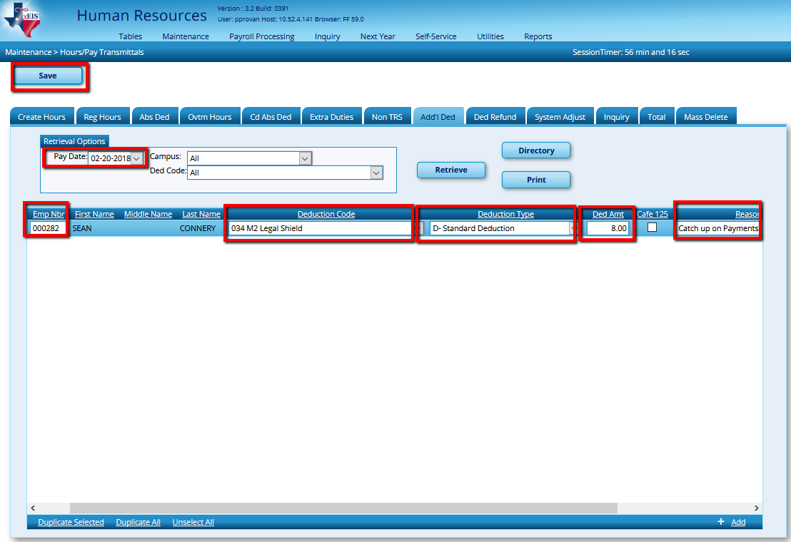

- Deduction Refunds – All Pay Types

Maintenance > Hours/Pay Transmittals > Deduction Refunds

This tab is used to maintain records of deduction refund transmittals for employee paychecks in which incorrect deductions were taken. This tab is used for correcting deduction errors.

- Enter the Pay date
- Click Retrieve
- Enter the Emp Nbr or choose Directory if unknown, then TAB
- Enter the Deduction Code
- Enter the Deduction Refund Amount
- Select Café 125 if the deduction was originally tax sheltered
- Enter the Reason for the Refund.
- Save.

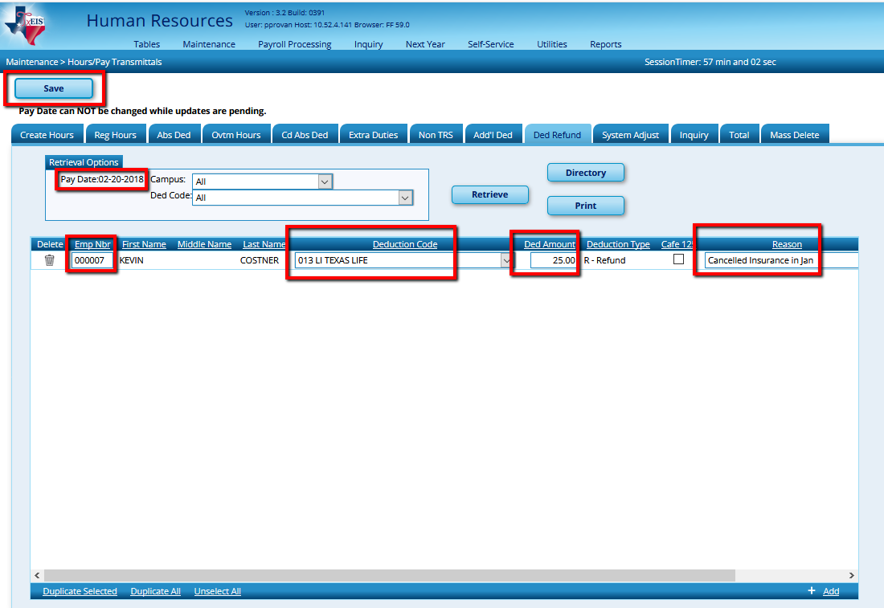
- System Adjustments – All Pay Types
Maintenance > Hours/Pay Transmittals > System Adjustments
Used to refund particular contributions normally taken during the payroll process. Select the Refund Type and enter the amount. In the Gross Amt field, type the employee’s gross monthly salary according to the refund type.
- If the refund type is TRS related (i.e., refund types I, P, S, or T), enter the TRS gross amount.
- If the refund type is Medicare related (i.e., refund type M), enter the Medicare gross amount.
- If the refund type is FICA related (i.e., refund types F or G), enter the FICA gross amount.
NOTE: Only process during Regular Payroll and not Supplemental.
NOTE: The system adjust tab was initially created to address refunds. To refund a contribution – enter a positive amount. To process an additional contribution – enter a negative amount.

_____12. Check the Contract Variance Report (HRS6050) and correct as needed
  - From Reports > HR Reports > Payroll Information Reports > Contract Balance Variance Report (HRS 6050). Run the report with a Maximum Acceptable Difference of “0” on all active employees. If you have variances greater than a few cents, you’ll want to determine why. Common problems include incorrect monthly pay rates, changes in pay rates during the year, ending one job and starting a new one without properly paying off the first. Make necessary adjustments and re-run until variance is only a few cents due to rounding.
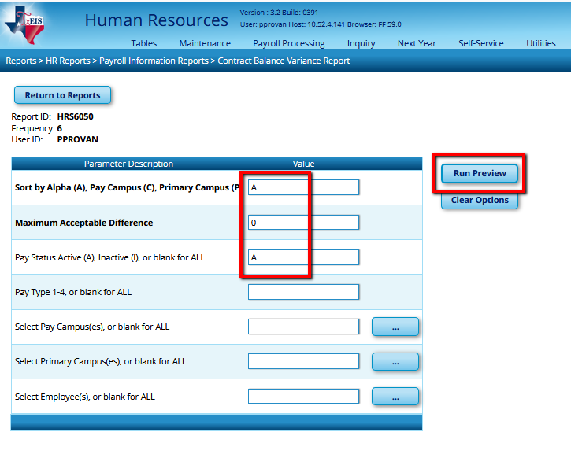

_____13. Verify transactions and Pre-Post report
Payroll Processing > Run Payroll
- Select the Pay Date

- Retrieve.
- Verify all current deductions are selected in the Deductions table at the bottom right of the screen and select
- Select Next.

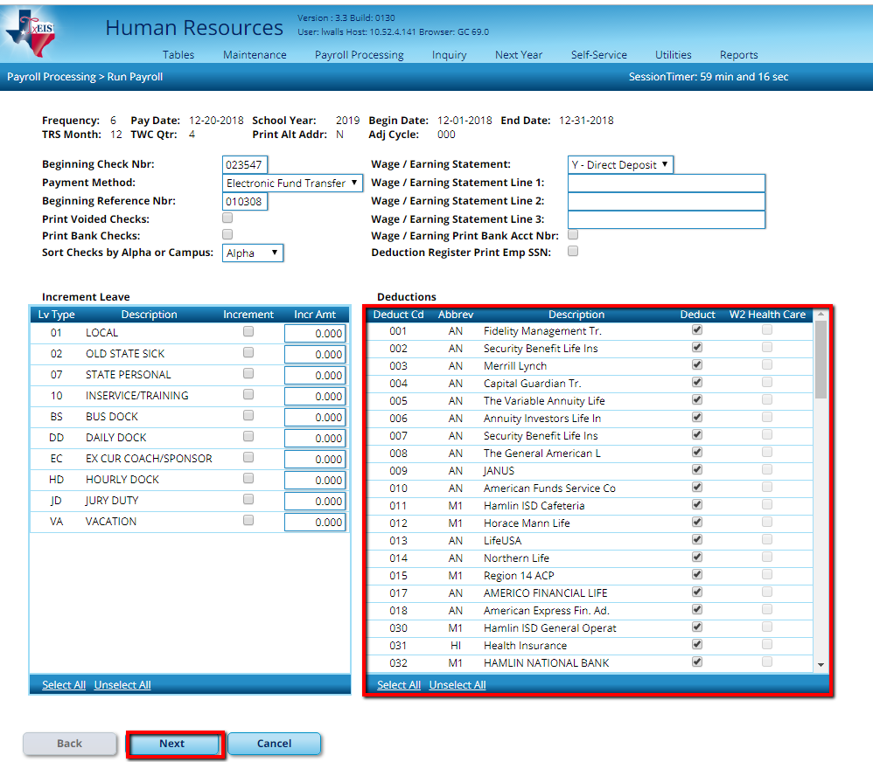
- Move employees to the right
- Select Next.
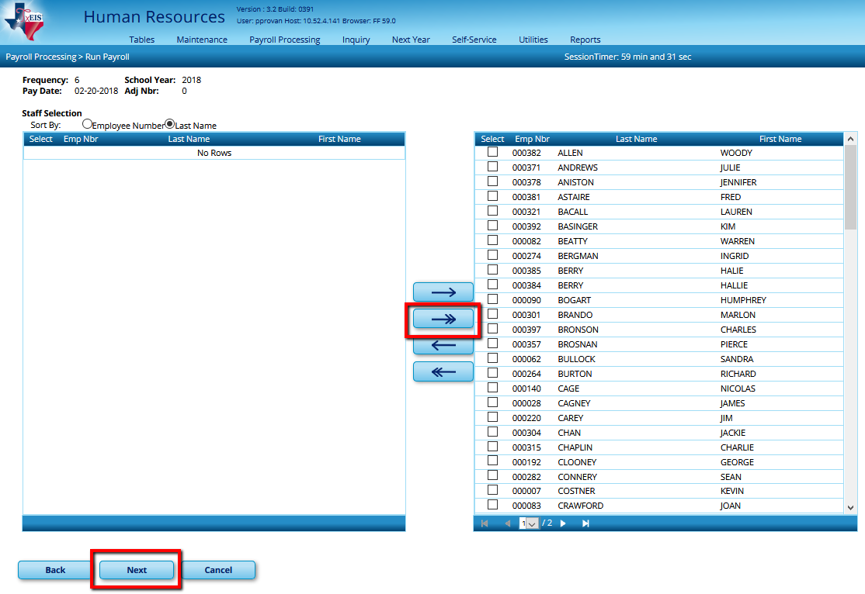

- Verify that the Payroll Calculations is selected for a regular payroll run.
- Select Next.
- Run Calculations.

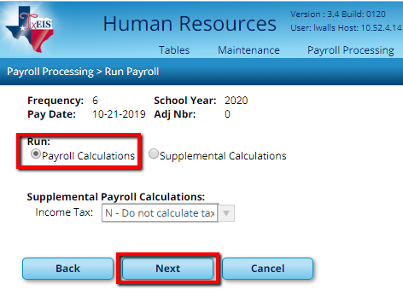

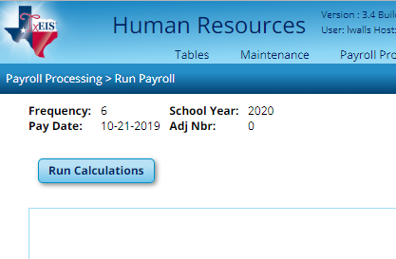

- Review the Payroll Calculations report for any payroll failures or warnings. Employees with a warning message will still get paid, but there is an issue that needs to be resolved. Employees with a failure message will not receive a paycheck at all.
- Resolve all problems before continuing. When the reports indicated that No Errors were found, select Next.

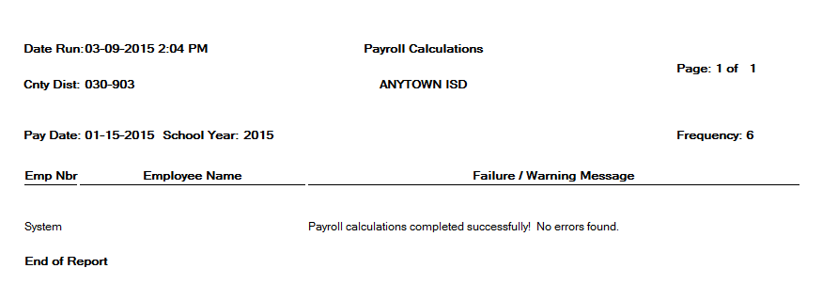

Proof the following Reports:

  - Transaction Proof list – verify transactions
    - Time Sheets
    - Leave
    - Substitute days
    - Extra Duty
    - Additional Pay
  - Payroll Earnings Register –
    - Compare to last month & be able to explain differences
    - Verify status changes that impact pay such as W-4 changes, stipends/extra duties changes, salary changes, medicare eligibility, TRS eligibility, remaining payments
  - Check Register – verify new employees are listed with a ck # (physical ck) or bank reference # (EFT)
  - Deduction Register – reconcile to bills and that new employees/terminated employees are reported accurately
  - Account Distribution Journal – last page may display errors. Correct as needed
  - Bank Account Listing – verify any new banks/accounts or account changes
  - General Journal – Verify accuracy. Watch especially for fund/fiscal years that are inaccurate
  - Account Code Comparison Report – should be blank. If not, add or change account codes as needed
  - Employee Leave Dock Report – Review for accuracy. Recommend alerting employees before running payroll if possible
  - Payroll Balancing Report

